Junction 25: New road layout for A358
13 January 2021
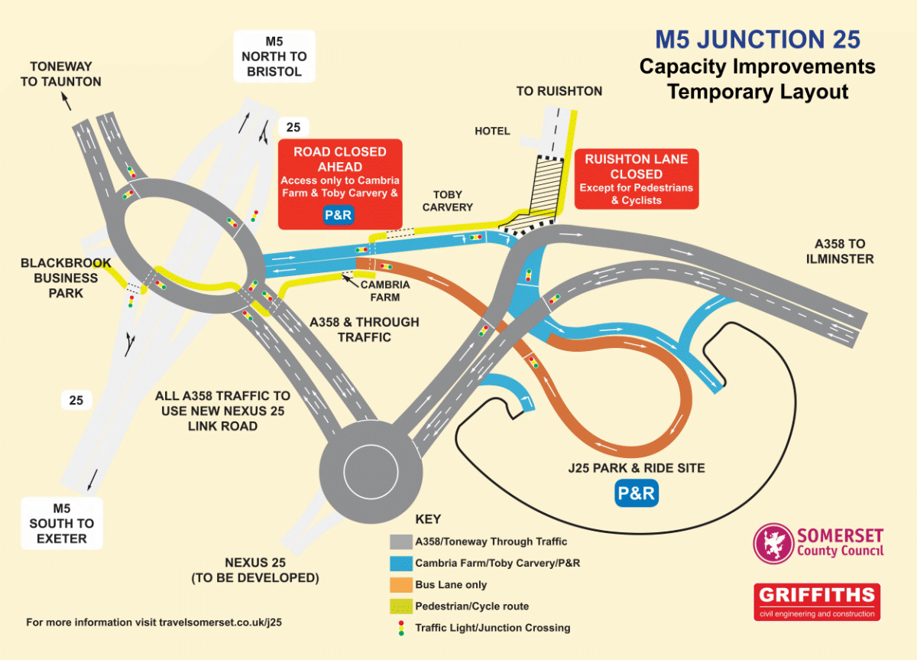
Motorists heading towards Taunton’s M5 Junction 25 will be using a new road layout from next week marking a big step forward in a major project to improve the junction.
The £19m scheme to upgrade Junction 25 and increase capacity is progressing well and is due to complete in the summer. The scheme includes an important new link road serving the town and motorway.
From Sunday night (17 January) the new Nexus link road will carry A358 traffic for the first time and motorists coming from this direction will now turn left just after the Gateway Park and Ride and follow the link road to a new roundabout, then on to the main Junction 25 roundabout.
The old section of the A358 between the Park and Ride and Junction 25 roundabout will temporarily be closed from Sunday until the project is complete, at which point it will reopen to eastbound traffic only.
“Redirecting A358 westbound traffic onto the new Nexus link road is an important part of the project,” said Cllr John Woodman, Somerset County Council’s Cabinet Member for Highways and Transport.
“It means we can complete the remaining work while keeping the network moving with minimal disruption. It’s a really positive step forward and I’d urge everyone to take a look at the information before you head out on your journey just to familiarise yourself with this change.”
Overall, J25 improvements include an enlargement of the roundabout, full signalisation and a widened eastern exit, a new roundabout to access the proposed Nexus 25 site, and safer pedestrian and cycling facilities.
Find out more about the new layout and sign up for e-newsletters at www.travelsomerset.co.uk/j25 and stay up to date by following @TravelSomerset on Twitter.

