CONFIRMATION OF THE DATES OF THE PERIOD FOR THE EXERCISE OF PUBLIC RIGHTS

The accounting records for the financial year to which the audit relates and all documents relating to those records must be made available for inspection by any person interested, during a period of 30 working days set by the smaller authority.
The period of 30 days starts with the day after all the Annual Governance Return requirements imposed on the smaller authority have been completed. SSM PC agreed an extended deadline with the external auditor, which has been further delayed due to the period of National Mourning. The period for the exercise of public rights will therefore commence following the PC approval meeting scheduled for 23 September 2022.

Name of smaller authority: STOKE ST MARY PARISH COUNCIL (SSM PC)

On behalf of the smaller authority, I confirm that the dates set for the period for the exercise of public rights are as follows:

Commencing on 26 September 2022

and ending on 7 November 2022

Signed: 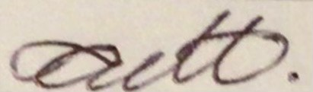

Role: RFO

